Probability distribution I:
Mean, Standard Deviation, Normal Distribution
Probability distribution topic will be divided into several lectures
(this is the first lecture)
Probability distribution function. Example 1.
- Assume 100 healthy patients had their PSA (i.e., Prostate Specific Antigen) level tested (i.e., prostate cancer screen). Each patient has his own test (PSA) results. Let us assume these values can range from
0 to 20 (e.g., 5.2, 4.327 etc)
- Note, that PSA levels can take on infinitely many values between 0 and 20 (i.e., we can assume it is a continuous variable), but let us assume for simplicity the following table …
Let us assume the following statistics about these patients and their test results. Step 1: build a table
PSA test results | Number of patients
0 | 1 (1 patient with PSA level at “0”)
5 | 2
7 | 8
8 | 18 (18 patients with PSA level at “8”)
10 | 40
12 | 19
13 | 8
15 | 3
20 | 1

Distribution of test values
Number of patients
0
5
10
15
20
25
30
35
40
45
0
5
10
15
20
25
Test result values

Step 2: Estimating probabilities
• We can also express Y-axis as a proportion (%) of patients in this group (over a total number, which is 100 – it will not be 100 patients always – this is just an example)
PSA test results | Proportion/fraction of patients
0 | 1/100
5 | 2/100
7 | 8/100
8 | 18/100
10 | 40/100
12 | 19/100
13 | 8/100
15 | 3/100
20 | 1/100
Note, the distribution is the same.
Proportion (%) of patients
0
0.05
0.1
0.15
0.2
0.25
0.3
0.35
0.4
0.45
0
5
10
15
20
25
Test results
Y axis reflects probabilities for each test result (probability distribution).
p(test results=x)
0
0.05
0.1
0.15
0.2
0.25
0.3
0.35
0.4
0.45
0
5
10
15
20
25
Test results values

Describing the distribution
- It basically describes a probability that a random variable (test result) will take some specific value.
- We can approximately say that 40% of population (out of our 100 patients) will have PSA level =10.
- At the same time, if I take any PSA result at random (from this patient population), the approximate probability that this test result will have a value of 10 is 0.4 (40%)
- Note that this is a small example (if we add more patients, we would have more PSA levels, which could take any values between 0 and 20).
- Even if specific value is not in our table (i.e., 8.5), we can approximate its probability using this distribution graph.
Probability distribution function.

Example 2 (this is something we know)
• Let us assume we throw two dice and record the sum of their outcomes. What is the probability distribution of the outcomes?
Step number 1. Build a table.

Step 1: Build a table
Outcome results (sum) | # of outcomes
2 (1+1) | 1
3 (2+1,1+2) | 2
4 (1+3,3+1,2+2) | 3
5 (1+4,4+1,2+3,3+2) | 4
6 (1+5,5+1,2+4,4+2,3+3) | 5
7 (1+6,6+1,2+5, 5+2,3+4,4+3) | 6
8 (2+6,6+2,3+5,5+3,4+4) | 5
9 (3+6,6+3,4+5,5+4) | 4
10 (4+6,6+4,5+5) | 3
11 (5+6,6+5) | 2
12 (6+6) | 1
0
1
2
3
4
5
6
7
0
2
4
6
8
10
12
14
Sum of two dice
Number of possible outcomes for that sum
Step 2: Estimating probabilities
(dividing possible outcomes by the total number of outcomes)
Outcome results (sum) | Probability of particular of  outcome
2 (1+1) | 1/36
3 (2+1,1+2) | 2/36
4 (1+3,3+1,2+2) | 3/36
5 (1+4,4+1,2+3,3+2) | 4/36
6 (1+5,5+1,2+4,4+2,3+3) | 5/36
7 (1+6,6+1,2+5, 5+2,3+4,4+3) | 6/36
8 (2+6,6+2,3+5,5+3,4+4) | 5/36
9 (3+6,6+3,4+5,5+4) | 4/36
10 (4+6,6+4,5+5) | 3/36
11 (5+6,6+5) | 2/36
12 (6+6) | 1/36
Probability distribution for the sum of two dice (probability mass function – since sum of two dice is a discrete random variable)
0.18
0.16
0.14
0.12
p(Sum of two dice=x)
0.1
0.08
0.06
0.04
0.02
0
2 3 4 5 6 7 8 9 10 11 12
Sum of two dice
- When we assume continuous random variables, we build a probability density function
(like in Example 1)
- When, we assume discrete random variables, we build a probability mass function (like in Example 2)
•
- Note that the probability of all possible outcomes would add up to 1.
- We can actually “add” the exact Y-values from these plots to estimate probability that the value reaches at least or at most a particular value.
(favorite at least and at most!!)

Probability that the Sum of two dice is at most 3
0.18
0.16
0.14
0.12
p(Sum of two dice=x)
0.1
0.08
0.06
0.04
0.02
2 3

Probability that the Sum is at most 3
p(Sum of two dice=x)

=1/36+ 2/36 = 3/36 (what falls in the box)
0.02
0.04
0.06
0.08
0.1
0.12
0.14
0.16
0.18
2
3

Probability that the Sum is <=3 (to the left of the line-- threshold)
p(Sum of two dice=x)
0.02
0.04
0.06
0.08
0.1
0.12
0.14
0.16
0.18
2
3
/36+
1
2
/36

Probability that the Sum is at least 10 (>=10) (to the right of the line-threshold) is 6/36
p(Sum of two dice=x)
0.02
0.04
0.06
0.08
0.1
0.12
0.14
0.16
0.18
2
3
10
11
12
3
/36 + 2/36 + 1/36 = 6/
36
Coming back to continuous random variables (i.e., test results) and probability density function:
p(test results=x)
0.05
0.1
0.15
0.2
0.25
0.3
0.35
0.4
0.45
0
5
10
15
20
25
Test results
Threshold=7
P(
test results <=7
)=
area under the curve
to the left of 7 (we will cover these calculations in the next lecture)
Finding mean (two dice example)
Outcome results (sum) | Probability of particular of  outcome
2 (1+1) | 1/36
3 (2+1,1+2) | 2/36
4 (1+3,3+1,2+2) | 3/36
5 (1+4,4+1,2+3,3+2) | 4/36
6 (1+5,5+1,2+4,4+2,3+3) | 5/36
7 (1+6,6+1,2+5, 5+2,3+4,4+3) | 6/36
8 (2+6,6+2,3+5,5+3,4+4) | 5/36
9 (3+6,6+3,4+5,5+4) | 4/36
10 (4+6,6+4,5+5) | 3/36
11 (5+6,6+5) | 2/36
12 (6+6) | 1/36

Let us list all of our outcome values :
• 2 3 3 4 4 4 5 5 5 5
6 6 6 6 6 7 7 7 7 7 7
8 8 8 8 8 9 9 9 9 10 10 10
11 11 12
Note, we can just add all these variables and divide this sum by the total number of possible outcomes (36) to get the Mean

OR Mean can be found as
• *1 +3*2+4*3+5*4+6*5+7*6+8*5+9*4+10*3+11*2+12*1
36
Alternatively,

Standard deviation
- Standard deviation reflects how close your values are to the mean.
- Step 0: Calculate Mean
- Step 1. Subtract Mean from each value and square the results.
- Step 2. Add these squared differences (found in Step 1) and divide this sum by the total number of outcomes
- Step 3. Take the square root of the final value

Standard deviation
• Assume your mean is 7, then the standard deviation is
(
2
-
7)^2+(
3
-
7)^2+(
3
-
7)^2+(
4
-
7)^2+(
4
-
7)^2+(
4
-
7)
^2 +…
(
11
-
7)^2+(
12
-
7)
^
2
36
Note, that we list ALL values (such as 2,3,3,4,4,4 etc – like on slide 23) NOT JUST 2,3,4,5 etc !!!!!
OR YOU CAN GROUP VALUES SO THAT (3-7)^2+(3-7)^2 = 2*(3-7)^2 ETC.

PE 1
• Let us assume we flip a coin 3 times. Build a probability distribution (called probability mass function) for the number of Tails that can occur out of 3 coin flips.

PE 2
- Let us assume we flip a coin 3 times. Use a probability distribution from Exercise 1 to estimate p(number of Tails =2) and p(number of Tails is at most 2)
PE 3
- Find the Mean of your distribution in Exercises 1

PE 4
• Find the standard deviation of your distribution in Exercise 1

Normal distribution (Gaussian)
- The most commonly used distribution in Biostatistics is Normal (also called
Gaussian) -- most of the naturally-occurring data sets follow normal distribution
- Normal Distribution has single pick at the center of the distribution
- Mean is the highest point (pick) of the distribution curve;
- Mean is equal to its median and mode (mode=value that appears most often)
- Total area under the curve is 1 – which corresponds to total probability (as always for probability distributions) and area to the right of its Mean is equal area to the left of its Mean
- Asymptotic -- the curve gets closer and closer to the X-axis, but never touches it. The tails are extended indefinitely in both directions (see images on the following slides).
- Normal distribution has “bell” shape and is symmetric about its Mean
- Spread of the distribution is determined by its standard deviation

Normal distribution (example)
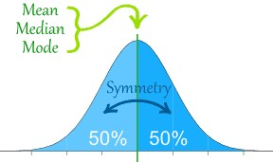
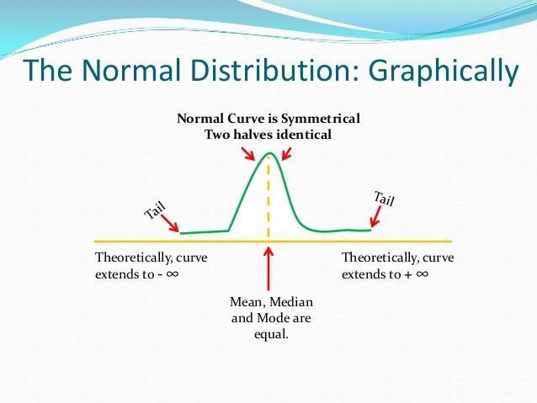
http://www.slideshare.net/jundumaug1/statistics-normal-distribution
- μ (reads as “Myu”) denotes Mean
- σ (reads as “Sigma”) denotes Standard Deviation
Let us introduce z (also called z-score), a number of SDs away from the mean.
- Note that z=1 corresponds to 1 σ (1 SD) away from the mean, z=2 corresponds to 2 σ (2 SD) away from the mean, etc.
- Practice exercises are due Oct 2nd, 2018
- I will post solutions on Oct 3rd, 2018
- We will continue the topic of distributions next week….

* (1/36)+ 3*(2/36) + 4*(3/36) +5*(4/36)+6*(5/36)+7*(6/36)+8*(5/36)+9*(4/36)+10*(3/36)+11*(2 /36)+12*(1/36) Which corresponds to the sum of values multiplied by their probabilities!!! (very important point to remember)

